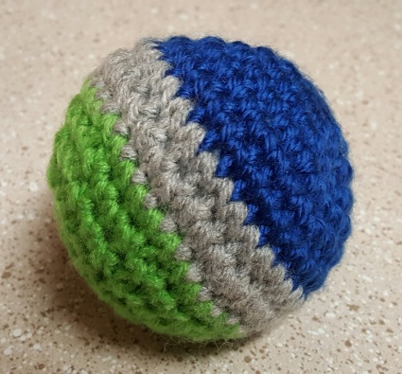Stress Balls

Supplies needed:
Hook size G or 5.00mm (you can adjust the size of your stress ball by changing the size of your hook up or down in size and using thicker or thinner yarn too)
Yarn, The colors for this ball I used Seahawk blue, green, and grey, the yarn that was used here was regular worsted, 4 ply. The smallest ball I made that’s in the picture on my blog “De-Stress With Stress Balls” I was using a fingerling type yarn. It’s used a lot for socks and finer, smaller projects like that.
Batting or sewing beads wrapped in the end of an old pair of panty hose. I used batting on this one.
A darning needle or tapestry needle
Either stitch markers or you can use a contrasting colored piece of thread and place it where you would have your marker.
And a pair of scissors

Stitches to know- ch-chain, sl st-slip stitch, sc-single crochet, 2sctog- 2 single crochet together or decrease, 2 sc in 1 sc is considered an increase, and….the magic ring. You can find instructions on the magic ring/circle here. This is a Blog site by Petals to Picots. She explains it very well.
To do a nice invisible 2sctog you take your hook and insert it in the front loop only of the next sc, again insert it into the following sc, front loop only, yo (yarn over) and pull it through only the first 2 loops Next, yo pull through the remaining loops.
Rnd 1. Create your magic ring with 6sc. I started this one with my Green color. This Ball will be done in the round without stopping at each row, I would suggest that you mark your rows just to help you keep count.
Rnd 2. 2sc in each sc all the way around (12sc)
Rnd 3. *2sc in 1st sc, 1sc in next sc* repeat from * until you complete the round. (18sc)
Rnd 4. *2sc in 1st sc, 1sc in each of the next 2 sc’s, * repeat to the end of the round (24sc)
Rnd 5. *2sc in 1st sc 1sc in the each of the next 3 sc’s* repeat to the end of the round (30sc)
Rnd 6. 1sc in each sc through the whole row (30sc)
If you wanted to do your colors half and half, you would change your colors after Row 7
Rnd 7-8. Now this is where if you would like to make the colors like I did you would change to your Grey color. 1sc in each sc through the whole row. (30sc)
Rnd 9. Change color to Blue and repeat row 6 (30sc)
Rnd 10. This is where we start our decrease. You will start with *2sctog and then 1sc in each of the next 3 sc’s.* then repeat around. (24sc)
Rnd 11. *2sctog, 1sc in each of the next 2sc’s* repeat around. (18sc)
You may want to start fill stuffing your ball, you can add more as you go. I recommend you stuff it tight as it will keep it’s shape better.
Rnd 12. *2sctog, 1sc in the next sc,* repeat around. (12sc)
Rnd 13. 2sctog 5 times. This will leave you with a few extra sc’s. This is where I stop and cut a nice long tail so that I can weave through the last sc’s with my darning needle and pull it tight. It closes up nicely. Then weave it in to the rest of the ball, and have it disappear!
If you would like to make these smaller, you just eliminate one of your increasing rows and one of your sc around rows. To make it larger, you can add 1 or more increasing rows (go by the sequencing we used) and add an extra sc in every sc row for every increasing row you add. I hope you enjoyed this little Team Colored Stress Ball, they're fun to have and use and safe to throw at a friend too… ;-) Click here for the PDF
Thanks for joining me.
Lani

